**TicTacToe User Manual**

This submission includes the following:

Game.java

GameClient.java

GameService.java

Player.java

Server.java

This program is meant to be run in the Eclipse IDE for Windows.

Steps:

1. Unzip the project folder
2. In you Eclipse IDE select File->OpenProjectFromFileSystem.
3. Select Directory and navigate to the Project 4 folder.
4. Load the Project5. If you do not load the entire project folder in, you will receive a runtime error.
5. First start the program from the Server.java file.3
6. Then run two instances of GameClient.java  
   To switch between consoles, select this button  
   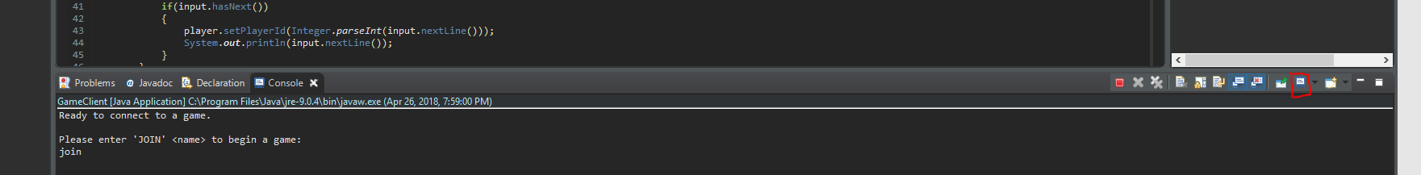  
   Output when started and ‘join <name>’ entered  
   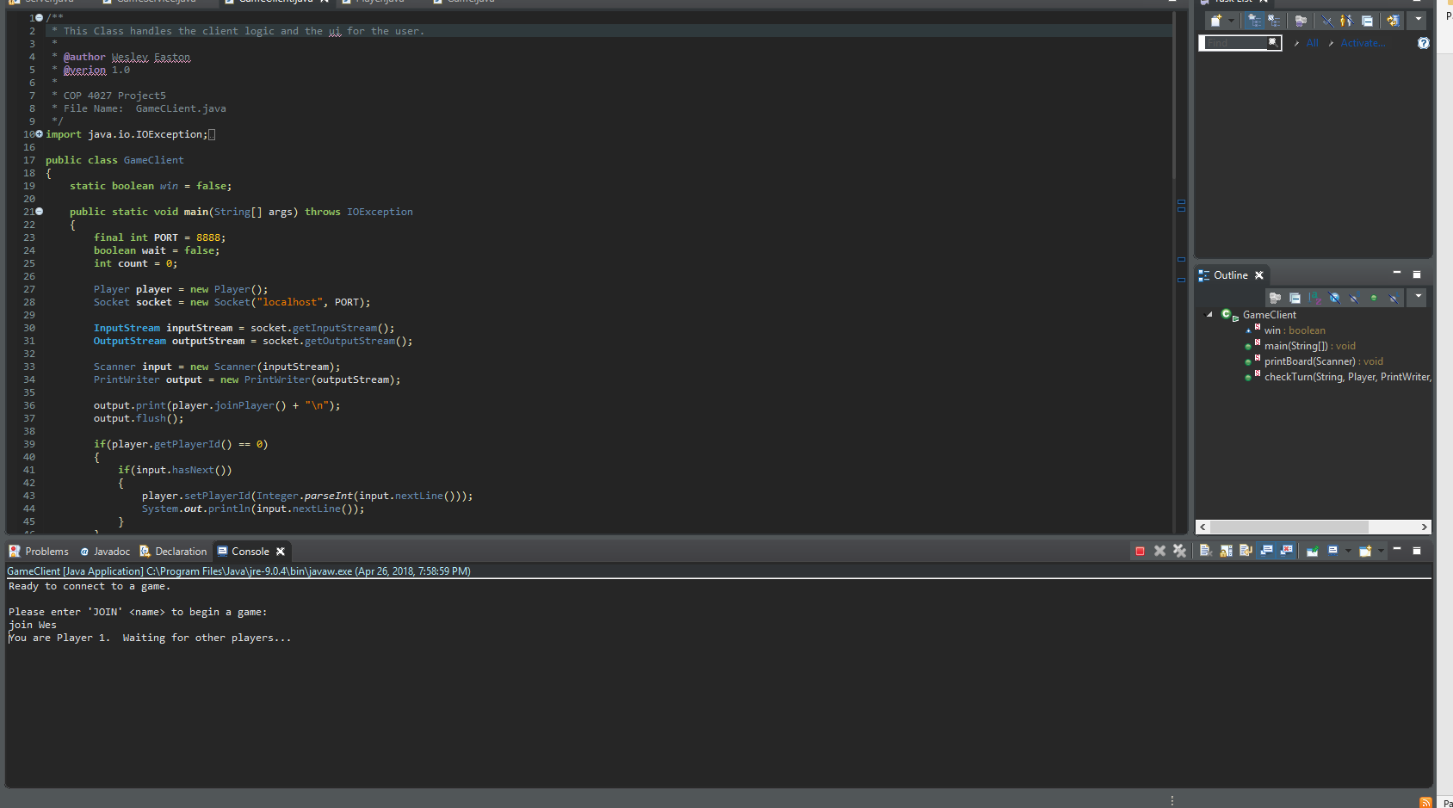

Output: All output will go to the GUI. Output will appear as follows:

